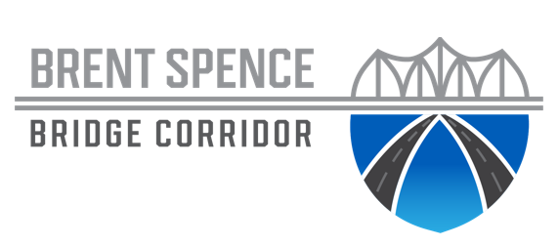

Industry Forum – Preliminary Agenda

# Industry Forum/Industry Outreach Meeting – Preliminary Agenda

June 7, 2022

9 am

Northern Kentucky Convention Center

|  |  |  |
| --- | --- | --- |
| **Time** | Function | **Participants** |
|  |  |  |
| 9am – 9:30am | Registration Opens/Networking |  |
| 9:30-9:45am | Welcome | Ohio DOT  KYTC |
| 9:45am – 11:00am | Project Overview / History / Procurement Presentation | Ohio DOT  KYTC |
| 11:00am – 12:00pm | Networking /Lunch (On Your Own) |  |
| 12:00pm – 7:00pm  June 8: 9am – 1pm | One-on-One Meetings (scheduled for one-hour sessions) One-on-One Meetings (continued) | Note: LOI response dependent. Meetings will be predetermined and prescheduled. Industry participants will be notified prior. |
|  |  |  |

## Additional Information:

Representatives from state agencies will be available to discuss Disadvantaged Business Enterprise considerations and outreach throughout the day. A Prime Exchange Networking Session, where you can meet Disadvantaged Business Enterprises (DBEs) who can help with meeting the DBE goal for this project, will be from 1 to 7 p.m. All interested lead firms are highly encouraged to attend.